**ICT272 Web Design and Development**

**Tutorial 3**

**Topic: Object-oriented programming**

**Submission: Submit to Moodle link (Week3)**

**Exercise 1 – Answer the following questions:**

* Explain how objects are related to each other in an app which lets user purchase products online.
* What is the difference between constructors and methods in classes?

**Exercise 2: Create an object from a class with a single field**

**- Write a program in C# to create a class called Person which has name and age**

**- create an object called "person1" with name "Alex" and age is 20 and print out these values**

1. Start your visual studio 2019
2. Click on Create a new project

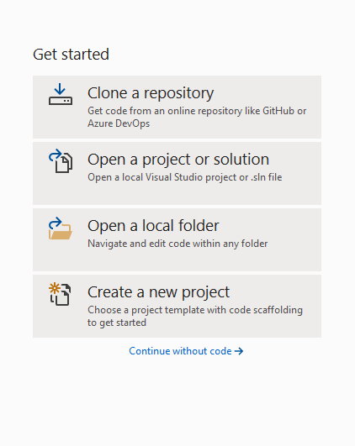

1. Search for console in search box and select “Console App (.Net Core)

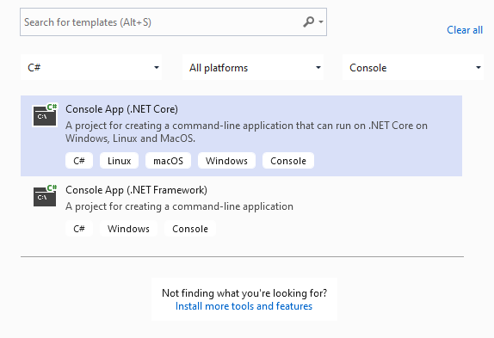

1. Name you project “Tutorial4Ex2” and click on Create
2. Inside the main function add the code below

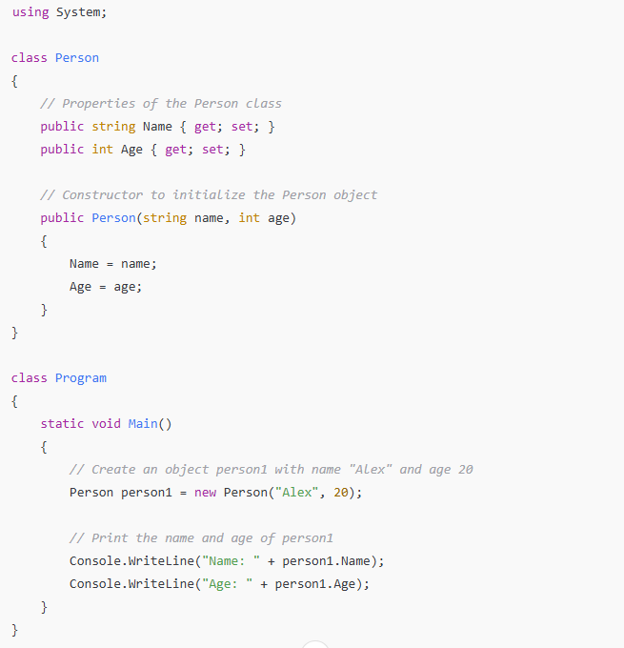

1. Click on start to run the application and see the output

**What to submit:**

1. The source code of Program file (Main function)
2. The output of the program

**Exercise 3: Create a class and use it with another class using access modifiers**

* **Create a class called Customer with three properties: id, name, and email. Include a constructor to initialize these properties.**
* **In the Program class, create two objects, Cust1 and Cust2, using the Customer class.**

1. Start your visual studio 2019
2. Click on Create a new project
3. Search for console in search box and select “Console App (.Net Core)
4. Name you project “Tutorial4Ex3” and click on Create
5. Create the below 2 classes in the namespace:

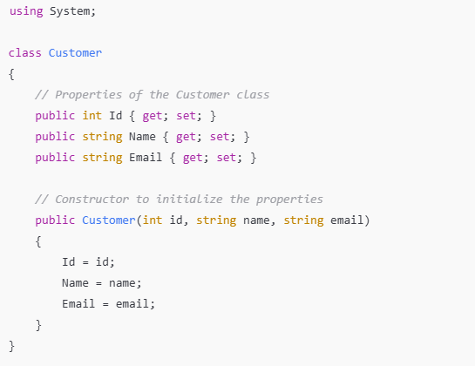

1. Click on start to run the application and see the output

**What to submit:**

1. The source code of Program file (Main function)
2. The output of the program

**Exercise 4**:

* Add another class called Product to the above namespace
* Create a list in the Customer class to hold multiple products

1. Create the Product class as below in the namespace:

1. Include the below namespace at the top to use Lists



1. ****Add the code below to the Customer Class
2. Create 3 Product objects and them to Cust1’s shopping list by adding below code to Main method in Program class
3. Add a method **DisplayCustomerInfo()** in the Customer class that displays the customer information and the shopping list of products.

**What to submit:**

1. The source code of Program file (Main function)

**END of Tutorial**